Website Planning Document

# The Mountain Spoke

Author: Stephen Sturdevant

# Site Purpose

Provide information about our retail store and services.

* bicycles
* bicycle parts
* bicycle repair
* tours

reflects their culture of bicycle enthusiasm with products, repair service, parts, and tour trips.

Target Audience

Focus on local/regional bicycle enthusiasts

Tour organization and sponsorship for serious cyclists from around the world.

# Site Map



# Color Scheme

BRIGHT YELLOW (CRAYOLA)

RUSTY RED

DEEP KOAMARU

PEACH

DARK LIVER

Main Color:

DEEP KOAMARU

Background:

RUSTY RED

Text:

PEACH

Headings:

DARK LIVER

Navigation:

BRIGHT YELLOW (CRAYOLA)

Color Palette

<https://coolors.co/fcac21-db2b39-29335c-f0cea0-534d41>

logo yellow #fcac21

# Typography

Headings: Righteous <https://fonts.google.com/specimen/Righteous>

Main Text: Oswald <https://fonts.google.com/specimen/Oswald>

<link href="https://fonts.googleapis.com/css?family=**Oswald|Righteous**" rel="stylesheet">

# Wire-Frame Sketches



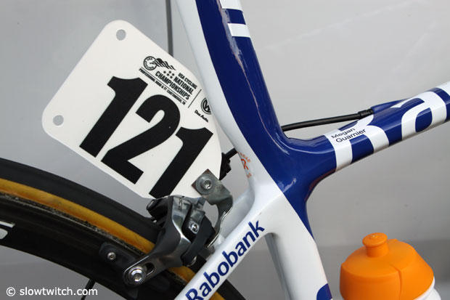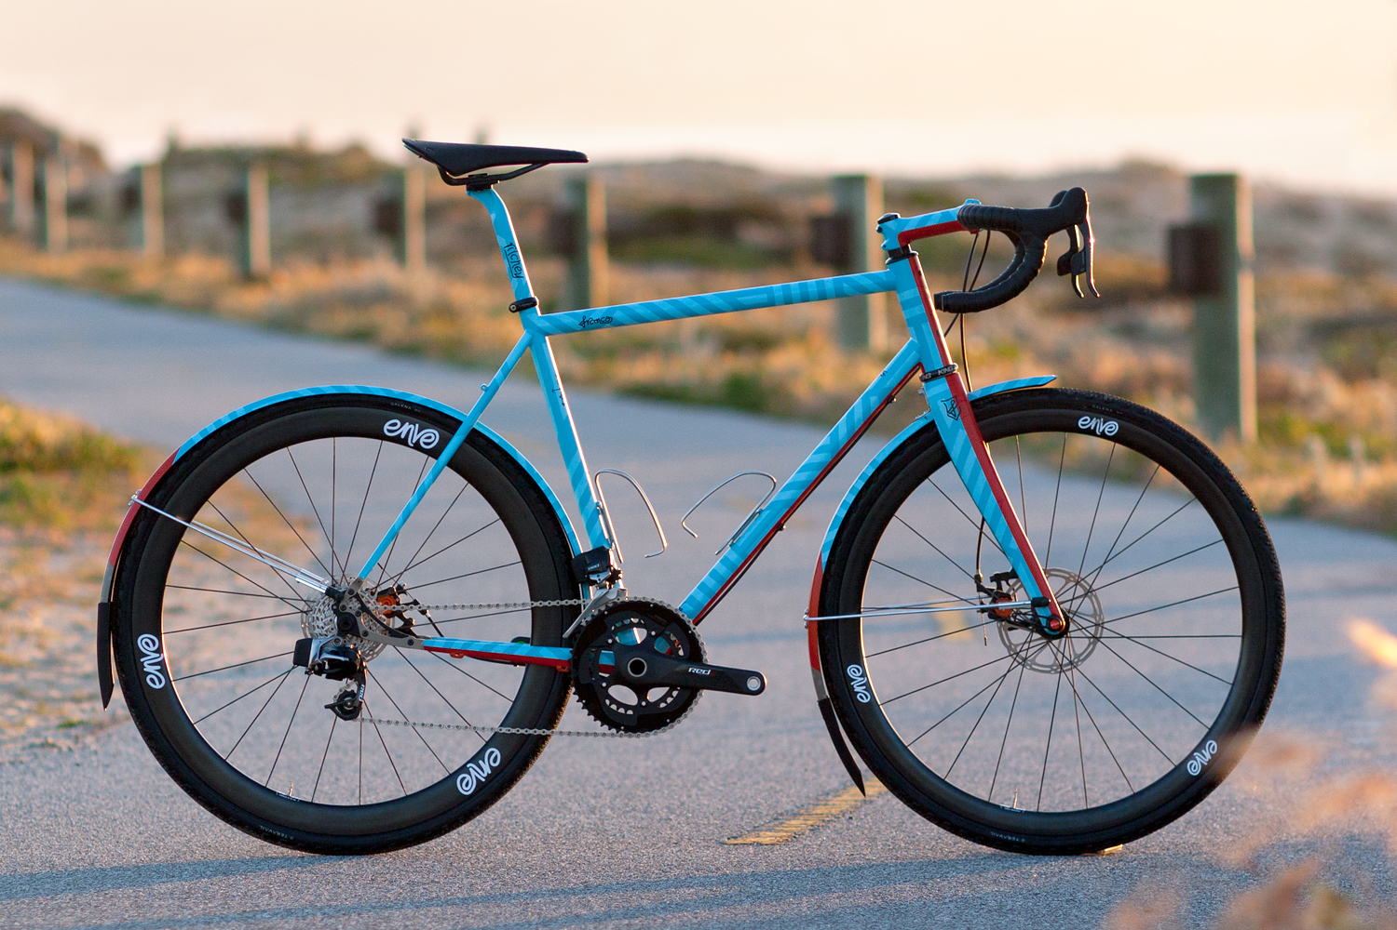

Top Products

Featured Events

The Mountain Spoke

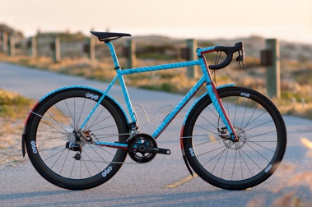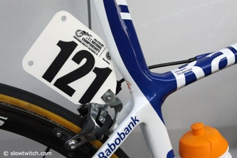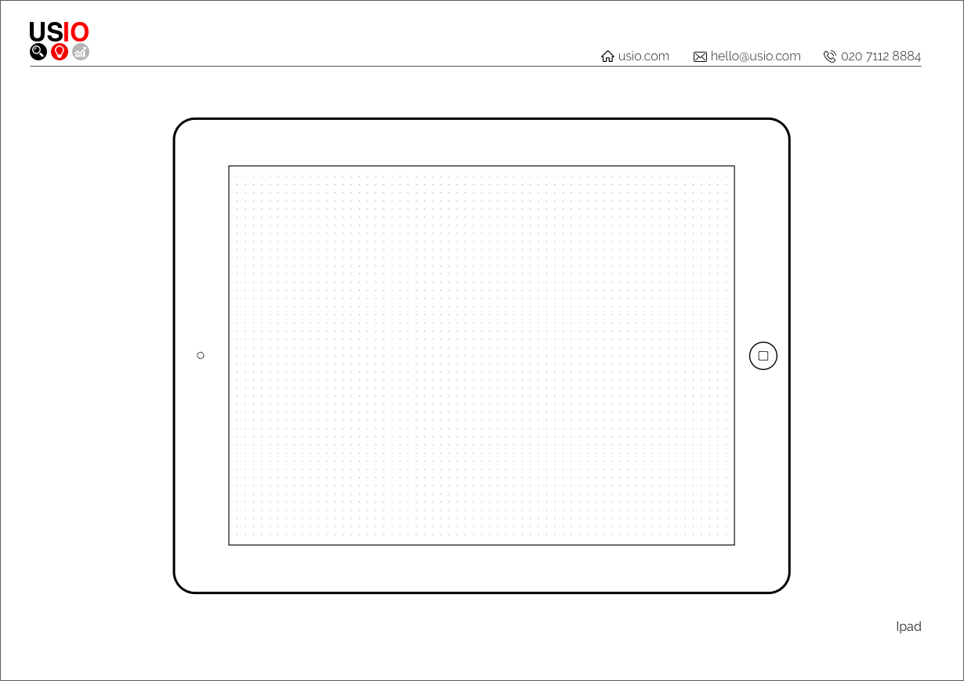

Tours Events Sales Service Contacts

BRIGHT YELLOW (CRAYOLA)

Top Products

Featured Events

The Mountain Spoke

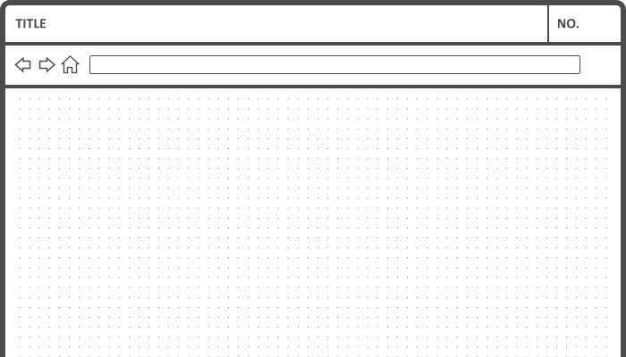

Top Products

Featured Events

Tours Events Sales Service Contacts

BRIGHT YELLOW (CRAYOLA)

The Mountain Spoke